**CSA0983:JAVA** **SUBON:15/07/2024**

**ASSIGNMENT-1**

**1**.Write a program to print all the composite numbers between a and b?

Sample Input:

A = 12

B = 19

Sample Output

14, 15, 16, 18

Test cases:

1. A = 11, B = 11

2. A = 20, B = 10

3. A = 0, B = 0

4. A = -5, B = 5

5. A = 7, B = -12

**PROGRAM:**

**public class CompositeNumbers {**

**public static void main(String[] args) {**

**int A = 12;**

**int B = 19;**

**for (int num = A; num <= B; num++) {**

**boolean isComposite = false;**

**for (int i = 2; i <= Math.sqrt(num); i++) {**

**if (num % i == 0) {**

**isComposite = true;**

**break;**

**}**

**}**

**if (isComposite) {**

**System.out.print(num + " ");**

**}**

**}**

**}**

**}**

**OUTPUT:**

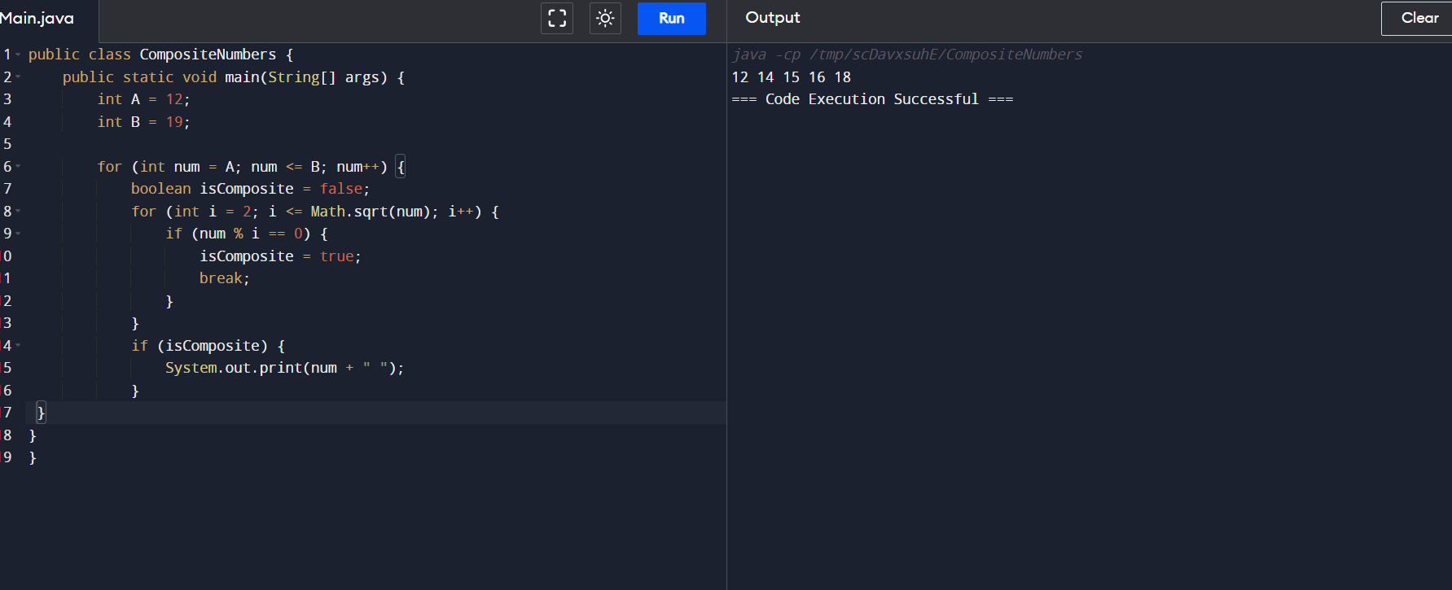

**2.** Write a program to print the numbers from M to N by skipping K numbers in between?

Sample Input:

M = 50

N = 100

K = 7

Sample Output:

50, 58, 66, 74, …..

Test cases:

1. M = 15, N = 05, K = 02

2. .M = 25, N = 50, K = 04

3. M = 15, N = 100, K = -02

4. M = 0 , N = 0 , K = 2

5. M = 200 , N = 200 , K = 50

**PROGARM:**

**public class SkipNumbers {**

**public static void main(String[] args) {**

**int M = 50;**

**int N = 100;**

**int K = 7;**

**for (int num = M; num <= N; num += K) {**

**System.out.print(num + ", ");**

**}**

**}**

**}**

**OUTPUT:** 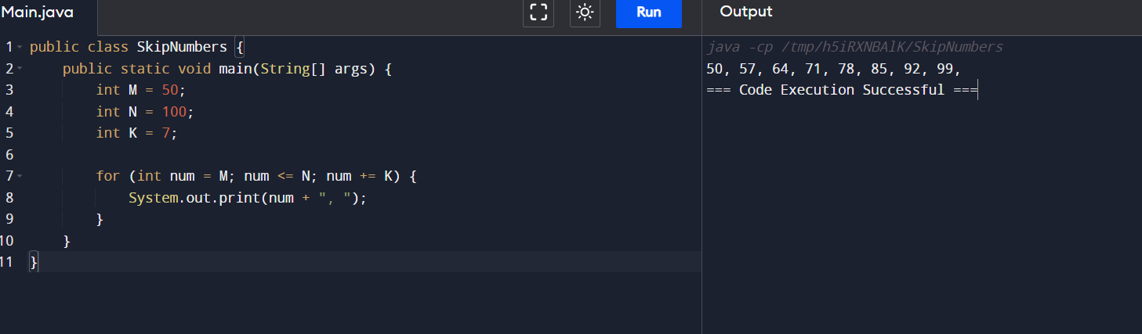

**3.** Write a program to enter the marks of a student in four subjects. Then calculate the total and aggregate, display the grade obtained by the student. If the student scores an aggregate greater than 75%, then the grade is Distinction. If aggregate is 60>= and <75, then the grade is First Division. If aggregate is 50 >= and <60, then the grade is Second Division. If aggregate is 40>= and <50, then the grade is Third Division. Else the grade is Fail.

Sample Input & Output:

Enter the marks in python: 90

Enter the marks in c programming: 91

Enter the marks in Mathematics: 92

Enter the marks in Physics: 93

Total= 366

Aggregate = 91.5

DISTINCTION

Test cases:

a) 18, 76,93,65

b) 73,78,79,75

c) 98,106,120,95

d) 96,73, -85,95

e) 78,59.8,76,79

**PROGRAM:**

**import java.util.Scanner;**

**public class GradeCalculator {**

**public static void main(String[] args) {**

**Scanner scanner = new Scanner(System.in);**

**int totalMarks = 0;**

**System.out.print("Enter the marks in python: ");**

**totalMarks += scanner.nextInt();**

**System.out.print("Enter the marks in c programming: ");**

**totalMarks += scanner.nextInt();**

**System.out.print("Enter the marks in Mathematics: ");**

**totalMarks += scanner.nextInt();**

**System.out.print("Enter the marks in Physics: ");**

**totalMarks += scanner.nextInt();**

**double aggregate = totalMarks / 4.0;**

**System.out.println("Total = " + totalMarks);**

**System.out.println("Aggregate = " + aggregate);**

**if (aggregate > 75) {**

**System.out.println("DISTINCTION");**

**} else if (aggregate >= 60) {**

**System.out.println("First Division");**

**} else if (aggregate >= 50) {**

**System.out.println("Second Division");**

**} else if (aggregate >= 40) {**

**System.out.println("Third Division");**

**} else {**

**System.out.println("Fail");**

**}**

**}**

**}**

**OUTPUT:**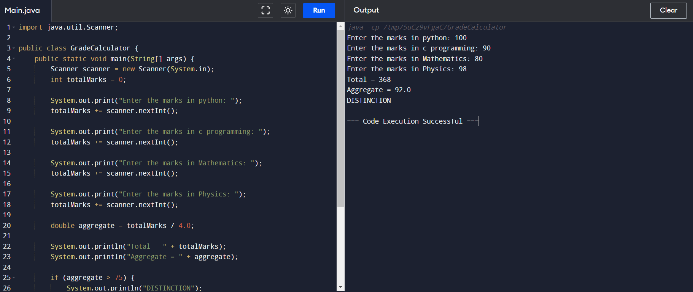

**4.**Write a program to calculate tax given the following conditions:

a. If income is less than or equal to 1,50,000 then no tax

b. If taxable income is 1,50,001 – 3,00,000 the charge 10% tax

c. If taxable income is 3,00,001 – 5,00,000 the charge 20% tax

d. If taxable income is above 5,00,001 then charge 30% tax

Sample Input:

Enter the income:200000

Sample Output:

Tax= 20000

Test cases:

1. 400700

2. 2789239

3. 150000

4. 00000

5. -125486

**PROGRAM:**

**import java.util.Scanner;**

**public class TaxCalculator {**

**public static void main(String[] args) {**

**Scanner scanner = new Scanner(System.in);**

**System.out.print("Enter the income: ");**

**int income = scanner.nextInt();**

**scanner.close();**

**double tax;**

**if (income <= 150000) {**

**tax = 0;**

**} else if (income <= 300000) {**

**tax = (income - 150000) * 0.1;**

**} else if (income <= 500000) {**

**tax = 15000 + (income - 300000) * 0.2;**

**} else {**

**tax = 45000 + (income - 500000) * 0.3;**

**}**

**System.out.println("Tax = " + tax);**

**}**

**}**

**OUTPUT:**

